Post Workout Recovery

Exercise | Weight | Reps/Time | Coaching Notes
Hamstring Stretch | BW | 20 sec each | Start in a seated position with legs spread. Stretch right, left and middle
Hollywood stretch | BW | 20 sec each | Sit, legs straight in front, cross one leg over the other (foot flat), rotate torso to same side to stretch back, use arms to support
Glute Stretch | BW | 20 sec each | Lie on your back, cross your right ankle over left thigh, bring both legs towards your chest grabbing the back of your thigh.
Supine Spine Twist | BW | 20 sec each | Lie on your back, extend your arms to make a “T” bring one leg up and over until on floor. Keep shoulders down
Sidelying Quad Stretch | BW | 20 sec each | Sidelying, grab your ankle and bend top leg toward your buttocks. Hold stretch – roll over onto your back for deeper stretch
90/90 stretches | BW | 20 sec | Form 90 degree angle with both legs. Hinge forward (hold) rotate right (hold) rotate left (hold) switch sides
Cobra | BW | 20 sec | Lie on stomach, keeping hips down, use arms to push chest awar from ground, relax abs and back, breath….
Calf Stretch | BW | 20 sec | Hands on floor, one leg back with knee straight heel flat on floor, the other leg crossed, bend knee to stretch achilies

This routine is designed to lengthen over active muscles and create optimum recovery and restore function. For optimal results, utilize Hypervolt before and after workout.

Inhibit all tight muscles with Hypervolt: particularly hip, glute, quad, adductors, hamstring, calf, and back

My recommendation: https://shop.lifetime.life/trainer/link/referral/trainerId/53949/
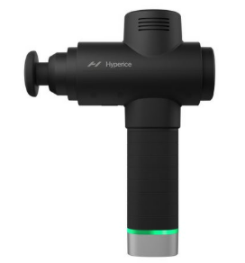

Recover with 30 grams of protein within 45-minutes of your workout
My recommendation: https://shop.lifetime.life/trainer/link/referral/trainerId/53949/
